BÀI TẬP 2
MÔN KĨ THUẬT LẬP TRÌNH
MỤC 1: Lưu Đồ Giải Thuật Chương 2.
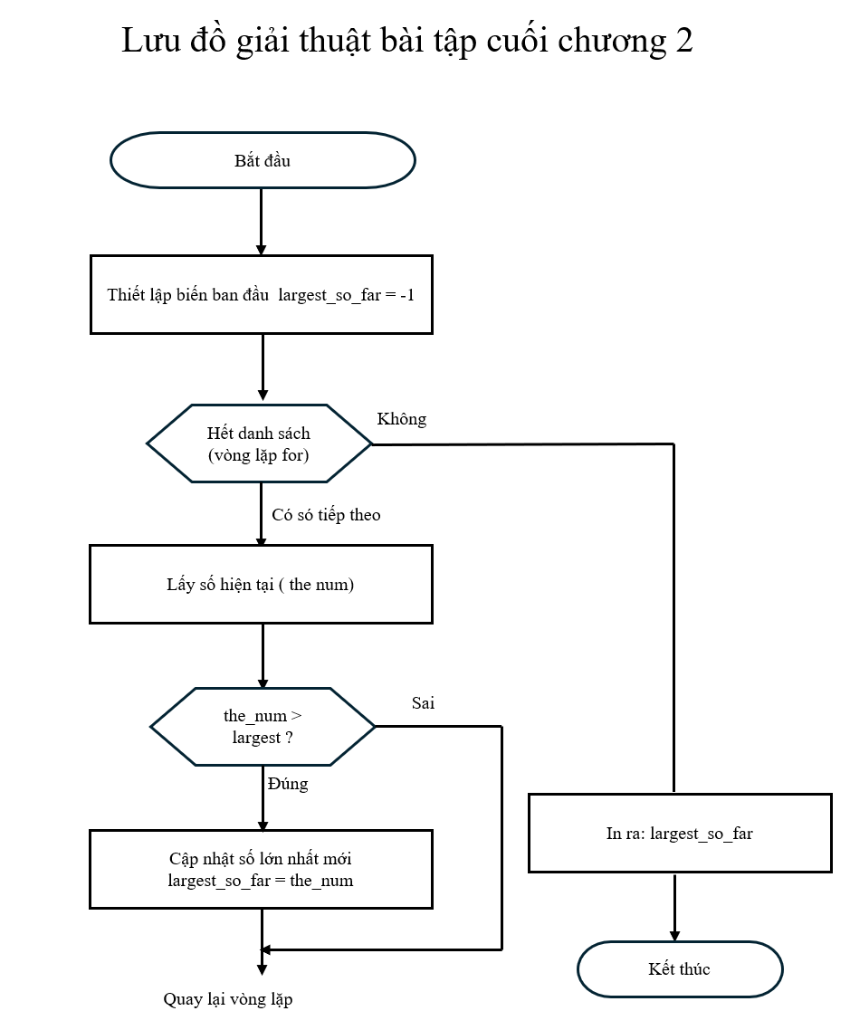
MỤC 2: Bài Tập Cuối Chương 2.
Exercise 2: Write a program that uses input to prompt a user for their name and then welcomes them.
Enter your name: Chuck Hello Chuck

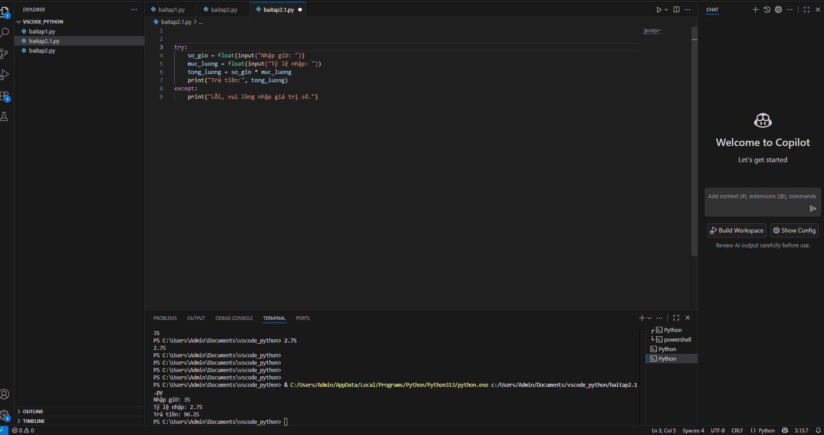
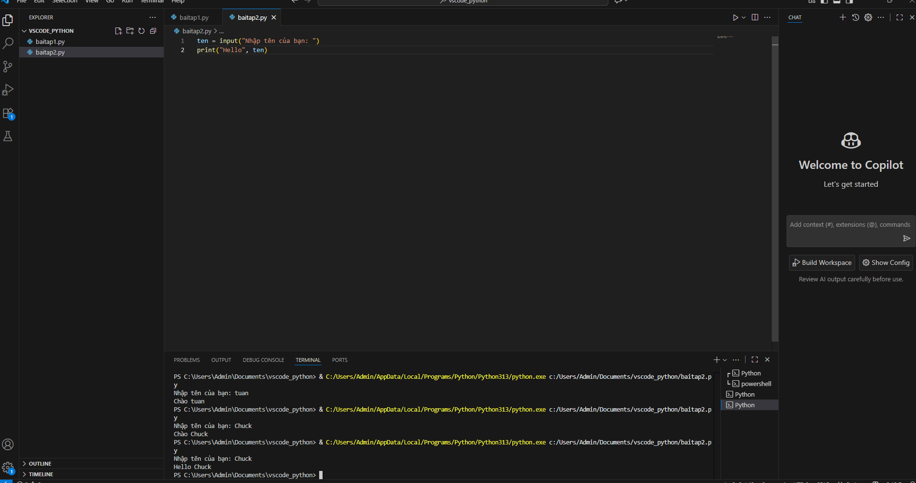
Exercise 3: Write a program to prompt the user for hours and rate per hour to compute gross pay. Enter Hours: 35 Enter Rate: 2.75 Pay: 96.25
Exercise 4: Assume that we execute the following assignment statements: width = 17 height = 12.0 For each of the following expressions, write the value of the expression and the type (of the value of the expression).
- width//2
- width/2.0
- height/3
- 4. 1 + 2 * 5
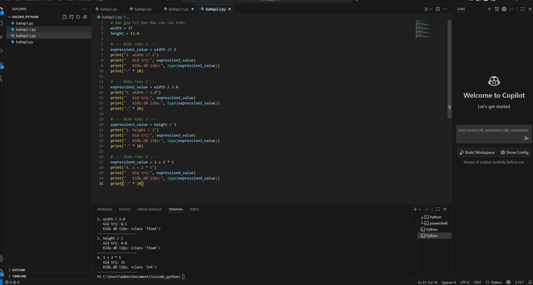
Exercise 5: Write a program which prompts the user for a Celsius temperature, convert the temperature to Fahrenheit, and print out the converted temperature
